Medical Supply Inventory Management Project

Name: Arrabiona Nagamani
Batch number: BN003
Project Title: Medical Supply Inventory Management

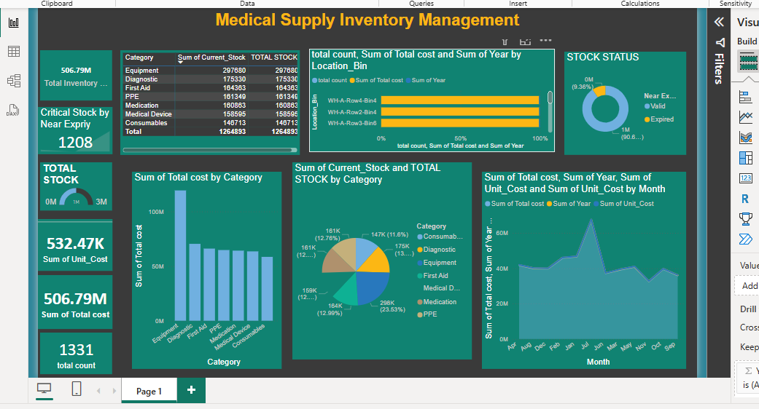
Step 1: Project Objective
- Manage and monitor stock of medical supplies.
- Track expiry, stock level, and total value.
- Help avoid wastage and improve purchase decisions.
Step 2: Load Your Dataset
- Open Excel.
- Click on File → Open → Select your file (CSV or Excel).
- Your dataset includes columns like:
  - Item Name
  - Category
  - Unit Cost
  - Current Stock
  - Total Cost &,Expiry Date
Step 3: Clean the Data
Go to Home → Find & Select → Go To Special → Blanks → Fill in missing values
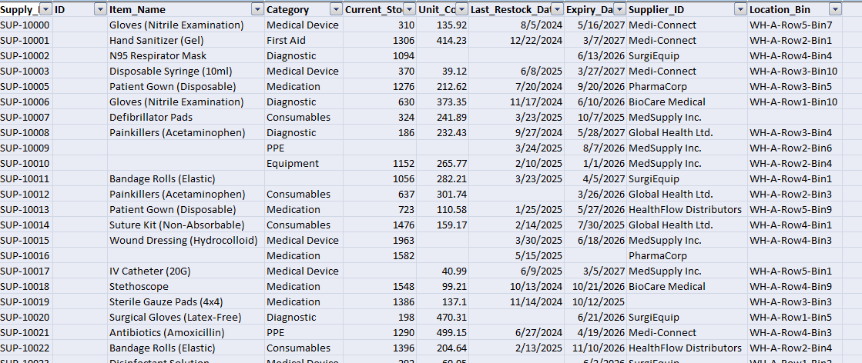
SuppluId used for Right function:
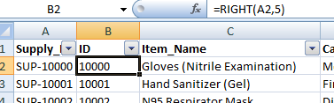

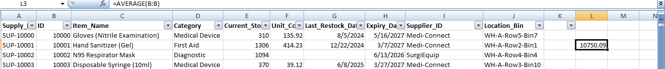
Average function used above sheet
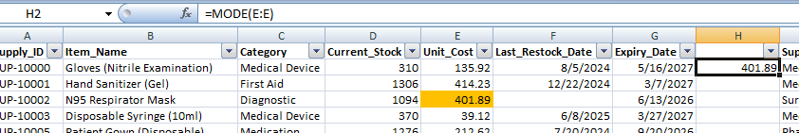
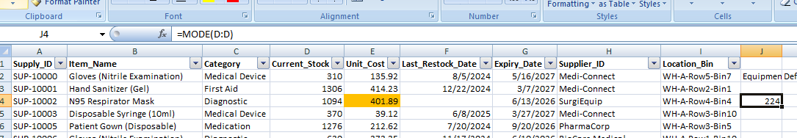

- Fill missing Category using formula =INDEX(H2:H1332,MODE(MATCH(H2:H1332,H2:H1332,0)))
- 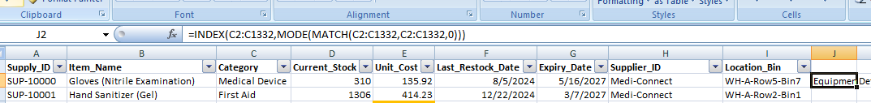
- Create “Total Cost” column:
= Unit Cost × Current Stock
Example: =D2 × E2
- =Table3[[#This Row],[Total Cost]]
- Create a “Status” column:
=IF(AND(G2>=TODAY(),G2<=TODAY()+90),"Expired","Valid")
Step 4: Create Pivot Tables
Pivot Table 1:
- Rows: Category
- Values: SUM of Total Cost, SUM of Current Stock
Pivot Table 2:
- Rows: Expiry Status
- Values: COUNT of Item Name
Pivot Table 3:
- Rows: Month (from Purchase/Expiry Date)
- Values: SUM of Total Cost
Step5: Insights
- Which category has the most cost?
- How many items are near expiry?
- Which months had higher costs?
- Which location stocks the most?

Step 1: Project Objective
This project is to manage medical supplies inventory effectively.
Goals:
Track stock levels.
Monitor expiry dates.
Analyze costs by category and month.
Improve decision-making for purchases and inventory turnover.

Step 2: Import Data
Imported medical supply inventory data (Excel/CSV file).
Key columns:
Item Name
Category (Equipment, Consumables, Medication, etc.)
Current_Stock
Unit_Cost
Total_Cost (calculated as Current_Stock × Unit_Cost)
Expiry Date
Location

Step 3: Data Cleaning and Transformation
Used Power Query Editor:
Removed duplicates and null values.
^{Create Measures}
^{Total Inventory Value}
Total Inventory Value = sum(medical_inventory_data[Total cost])
^{Critical Stock}
^{Critical Stock = COUNTROWS(}
FILTER(medical_inventory_data,(medical_inventory_data[Current_Stock]<=

medical_inventory_data[Last_Restock_Date].[Date])
Step 4: Build the Dashboard
Designed a Power BI dashboard with the following visuals:
KPI Cards
Total Stock
Total Cost
Near Expiry Count
Bar Chart
Total Cost by Category
Pie Chart
Current Stock Percentage by Category
Line Chart
Monthly Total Cost Trend
Donut Chart
Stock Status (Expired, Near Expiry, Valid)
Table
Detailed view of Item Name, Category, Stock, Unit Cost, Expiry

Step 6: Insights
Found which category is highest in cost.
Identified stock near expiry to prevent wastage.
Tracked monthly purchase trends to avoid overstocking.
Helped in improving inventory turnover ratio.

